Can you tell the difference?
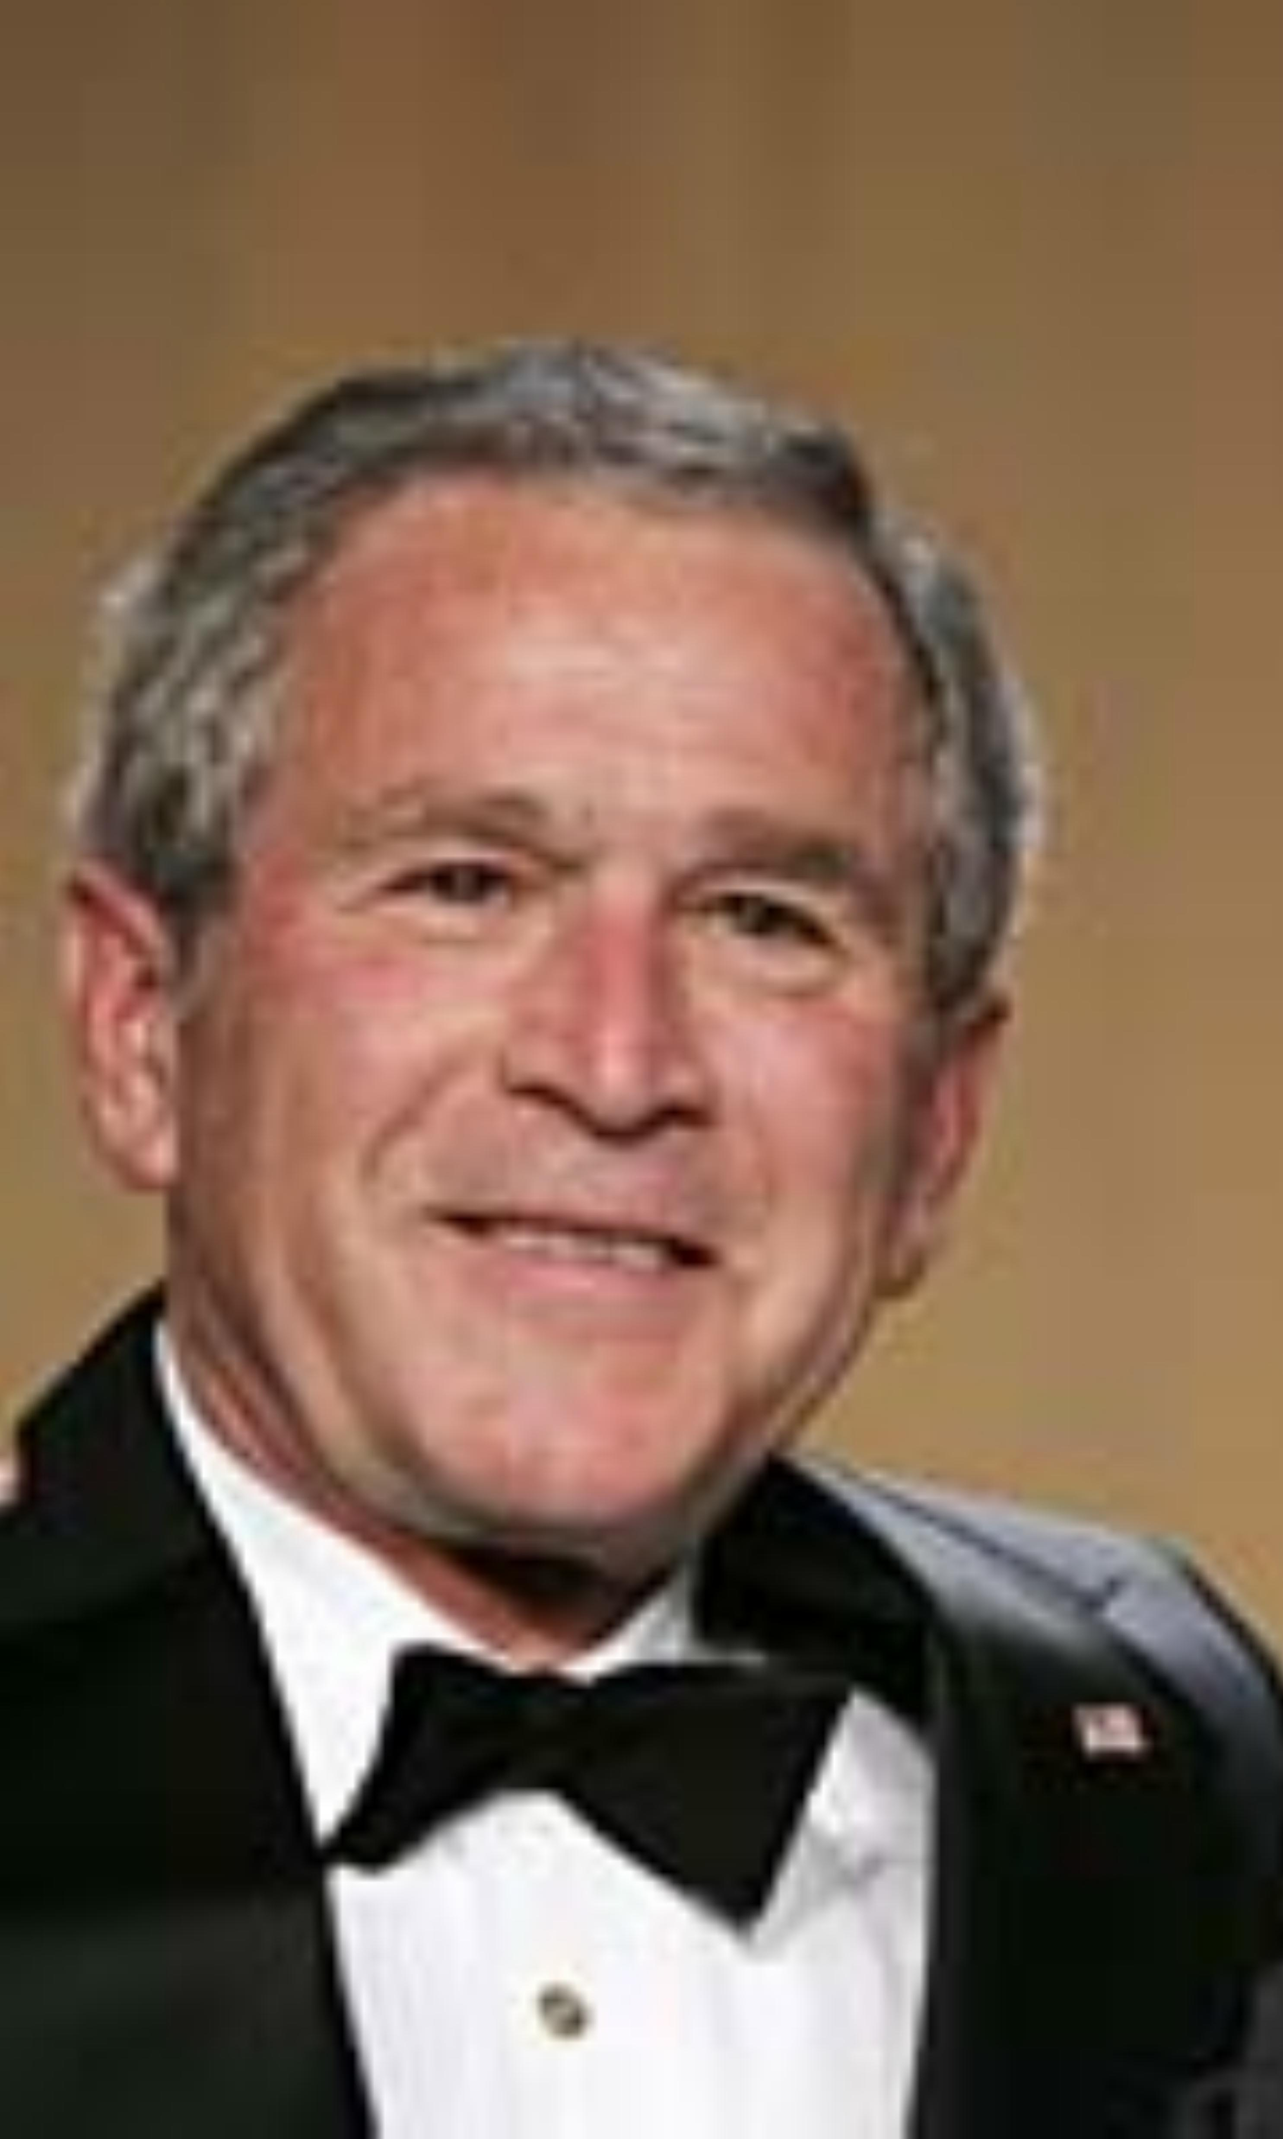 |  |  | 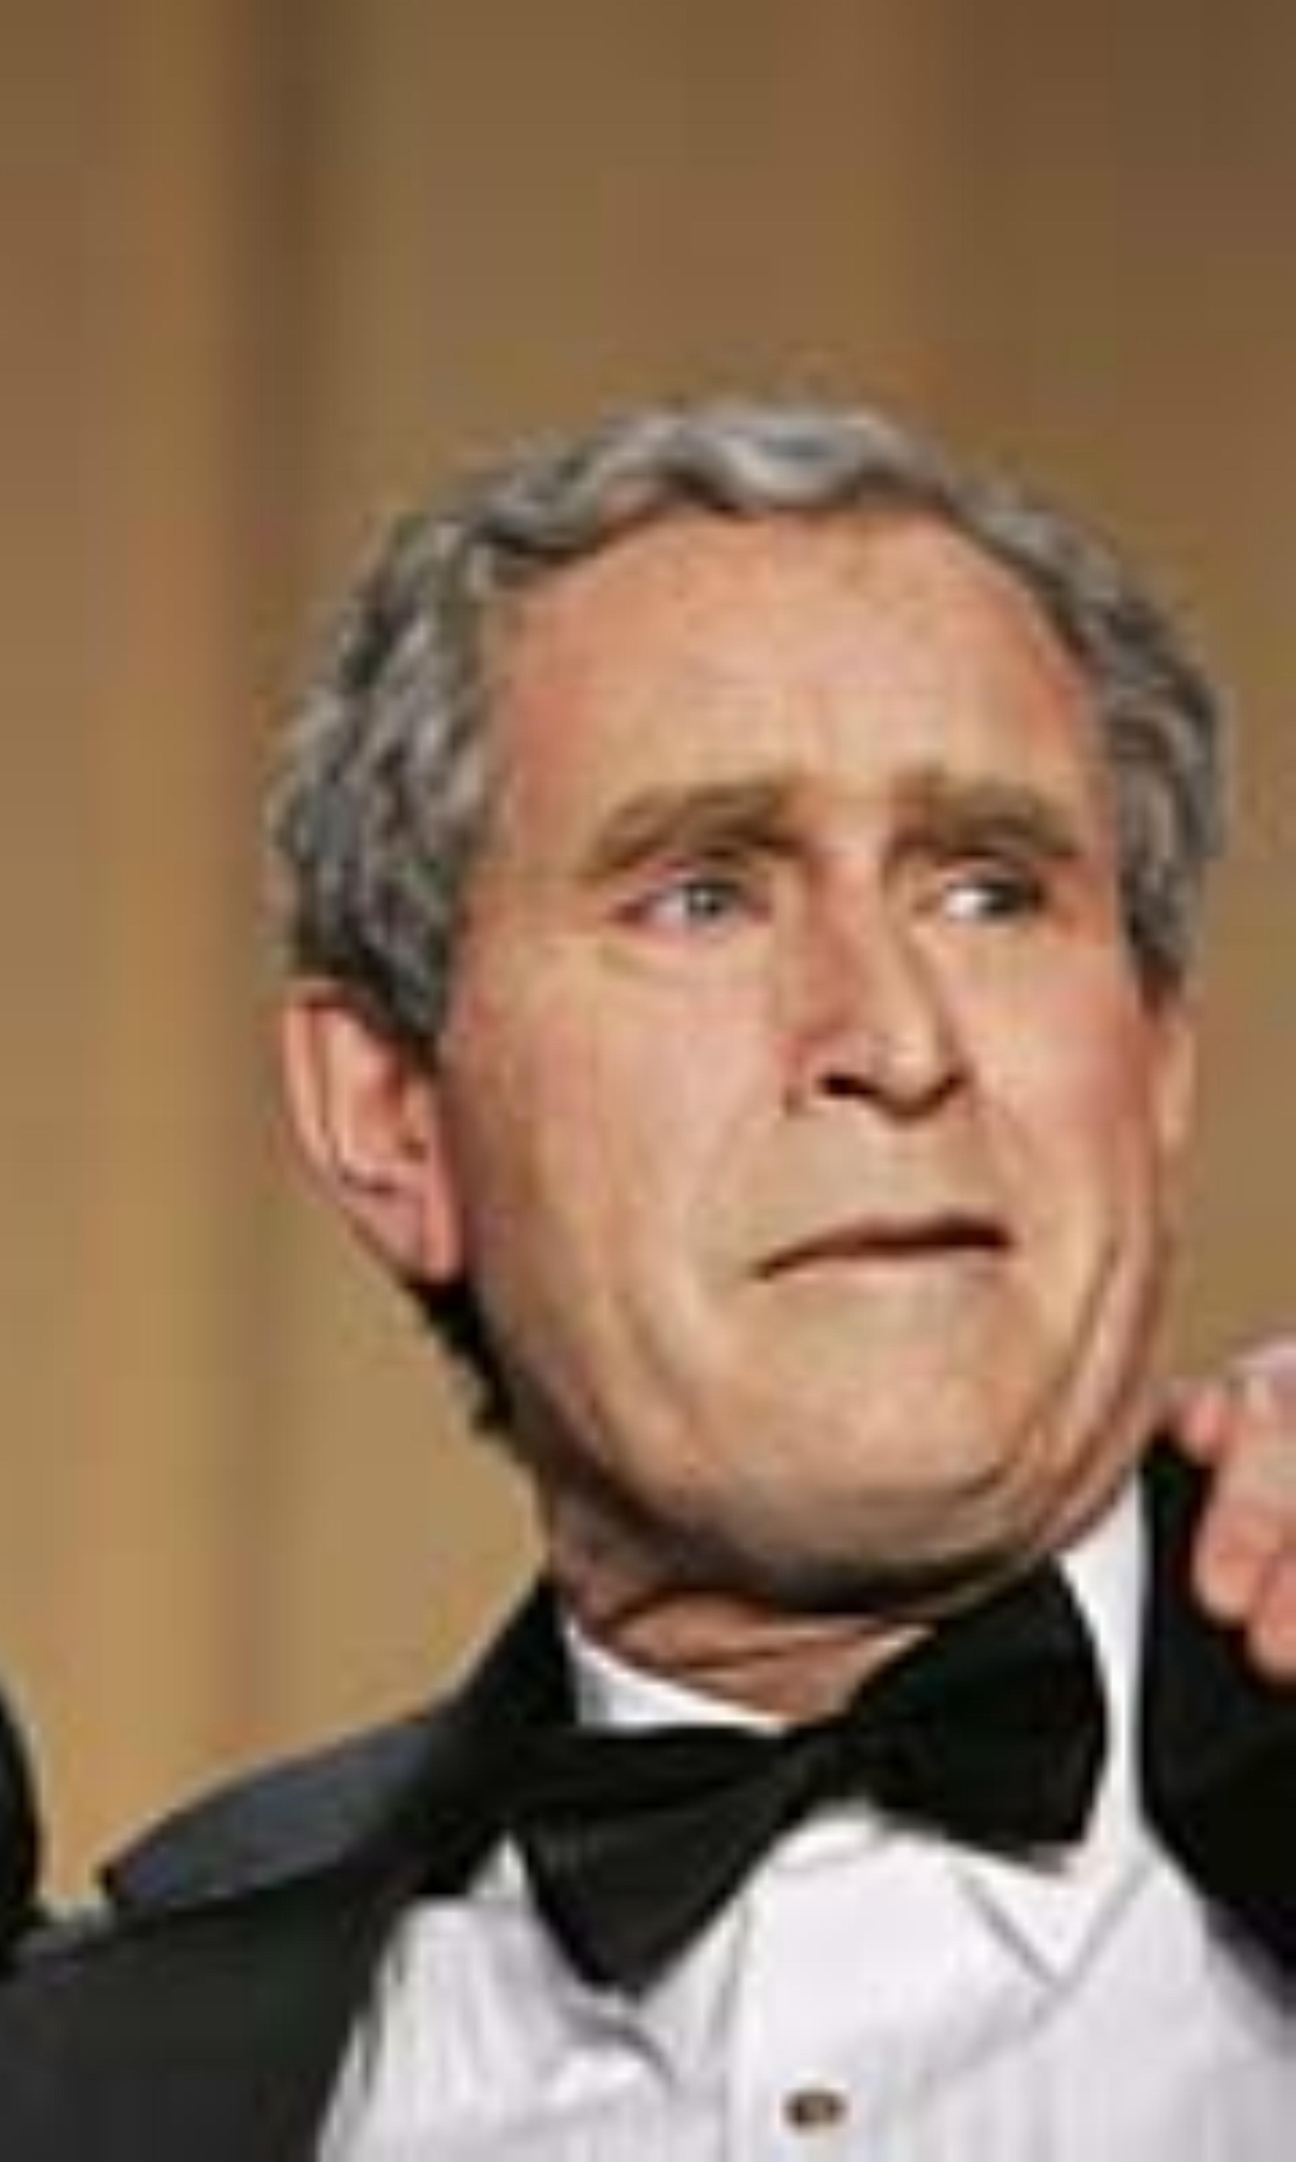
 | George W. Bush |  | George W. Bush Impersonator  Hired by Bush's handlers for the  2006 White House Press Corps Dinner
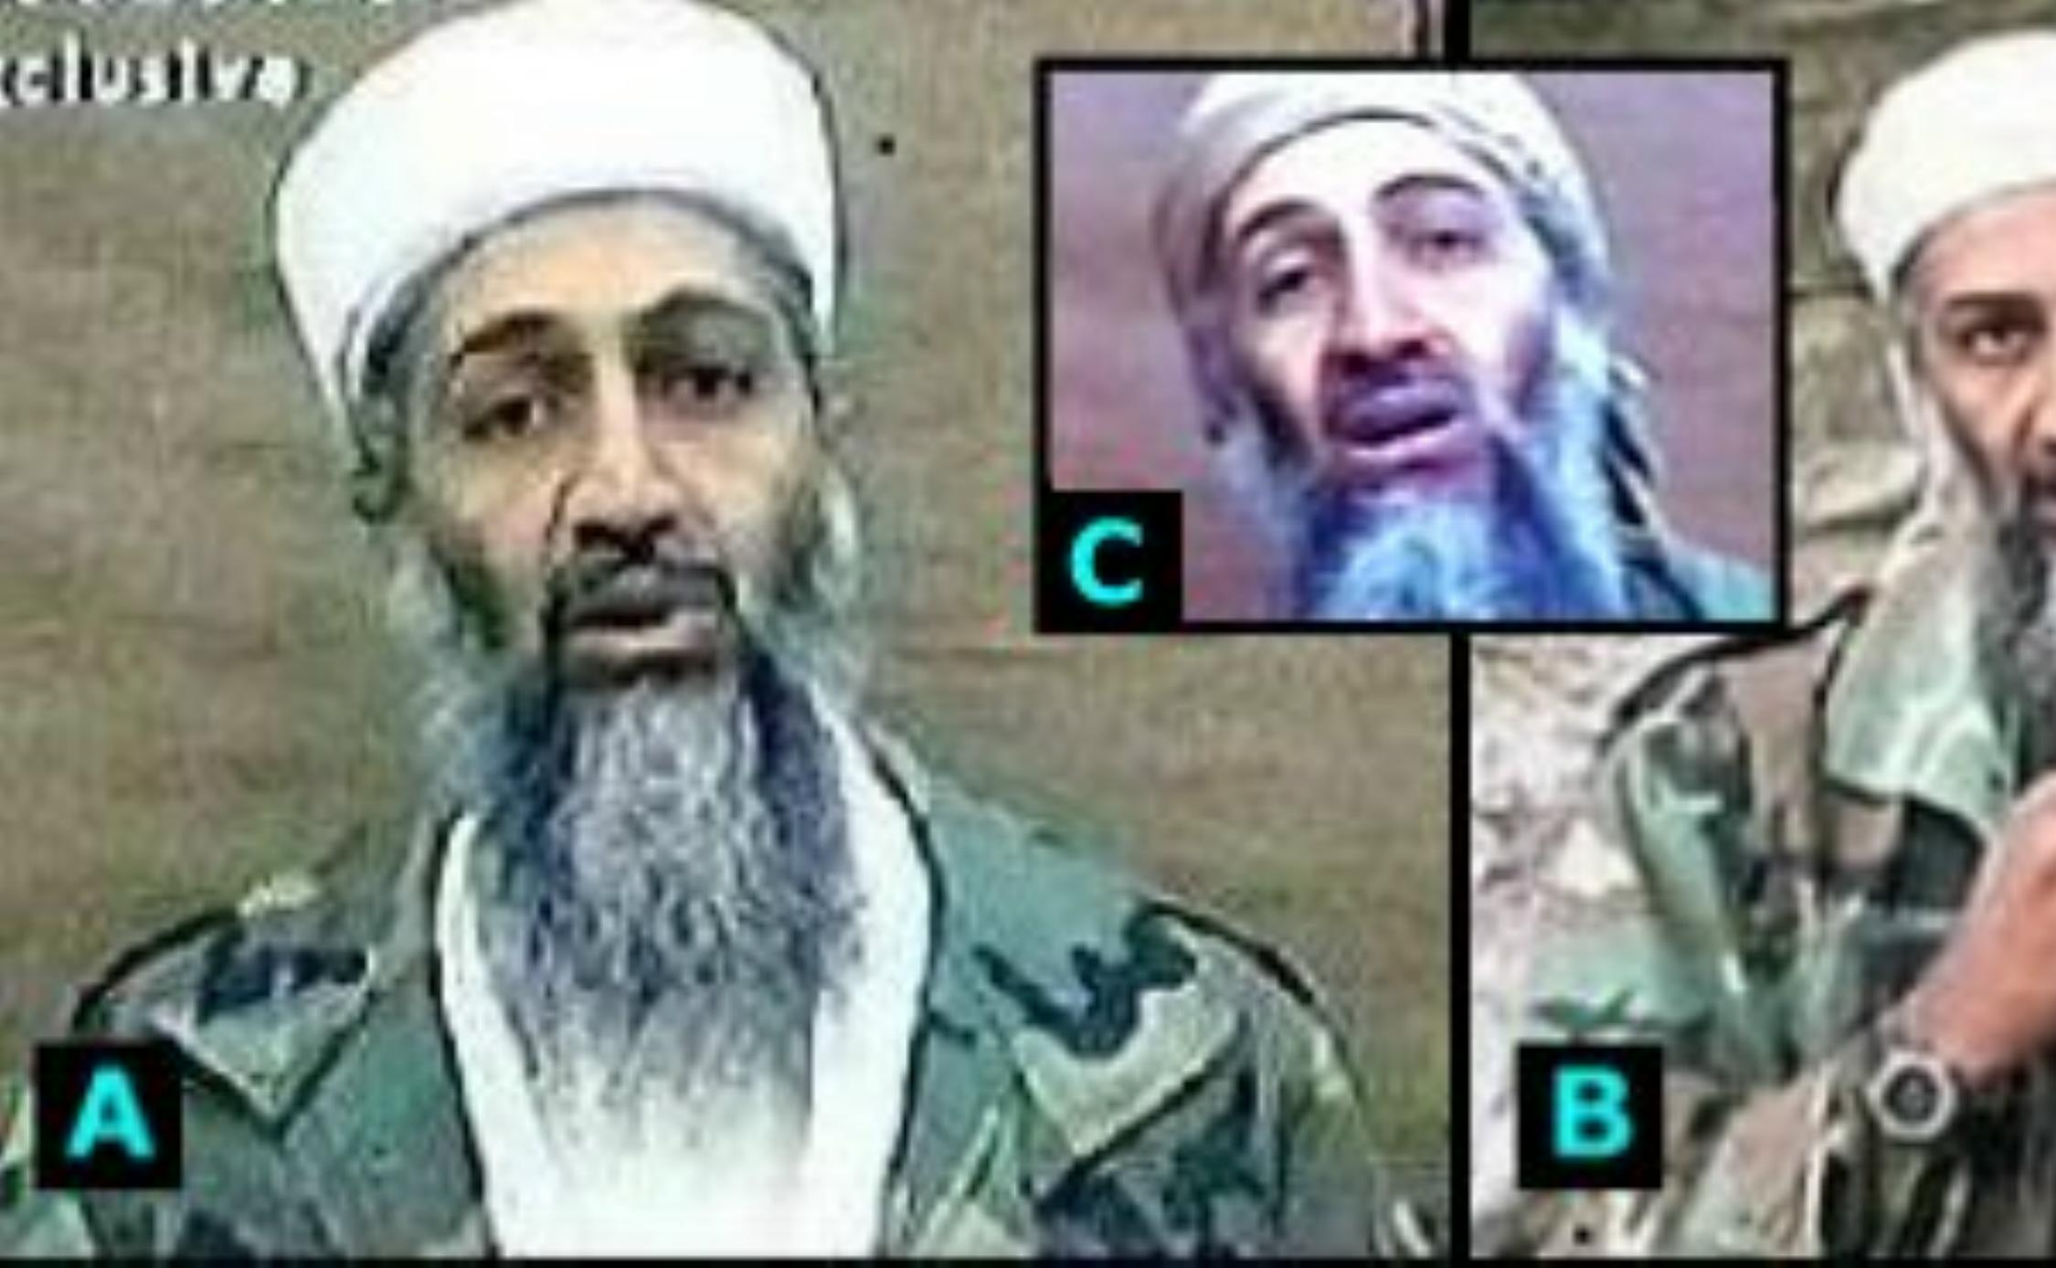 |  |  | 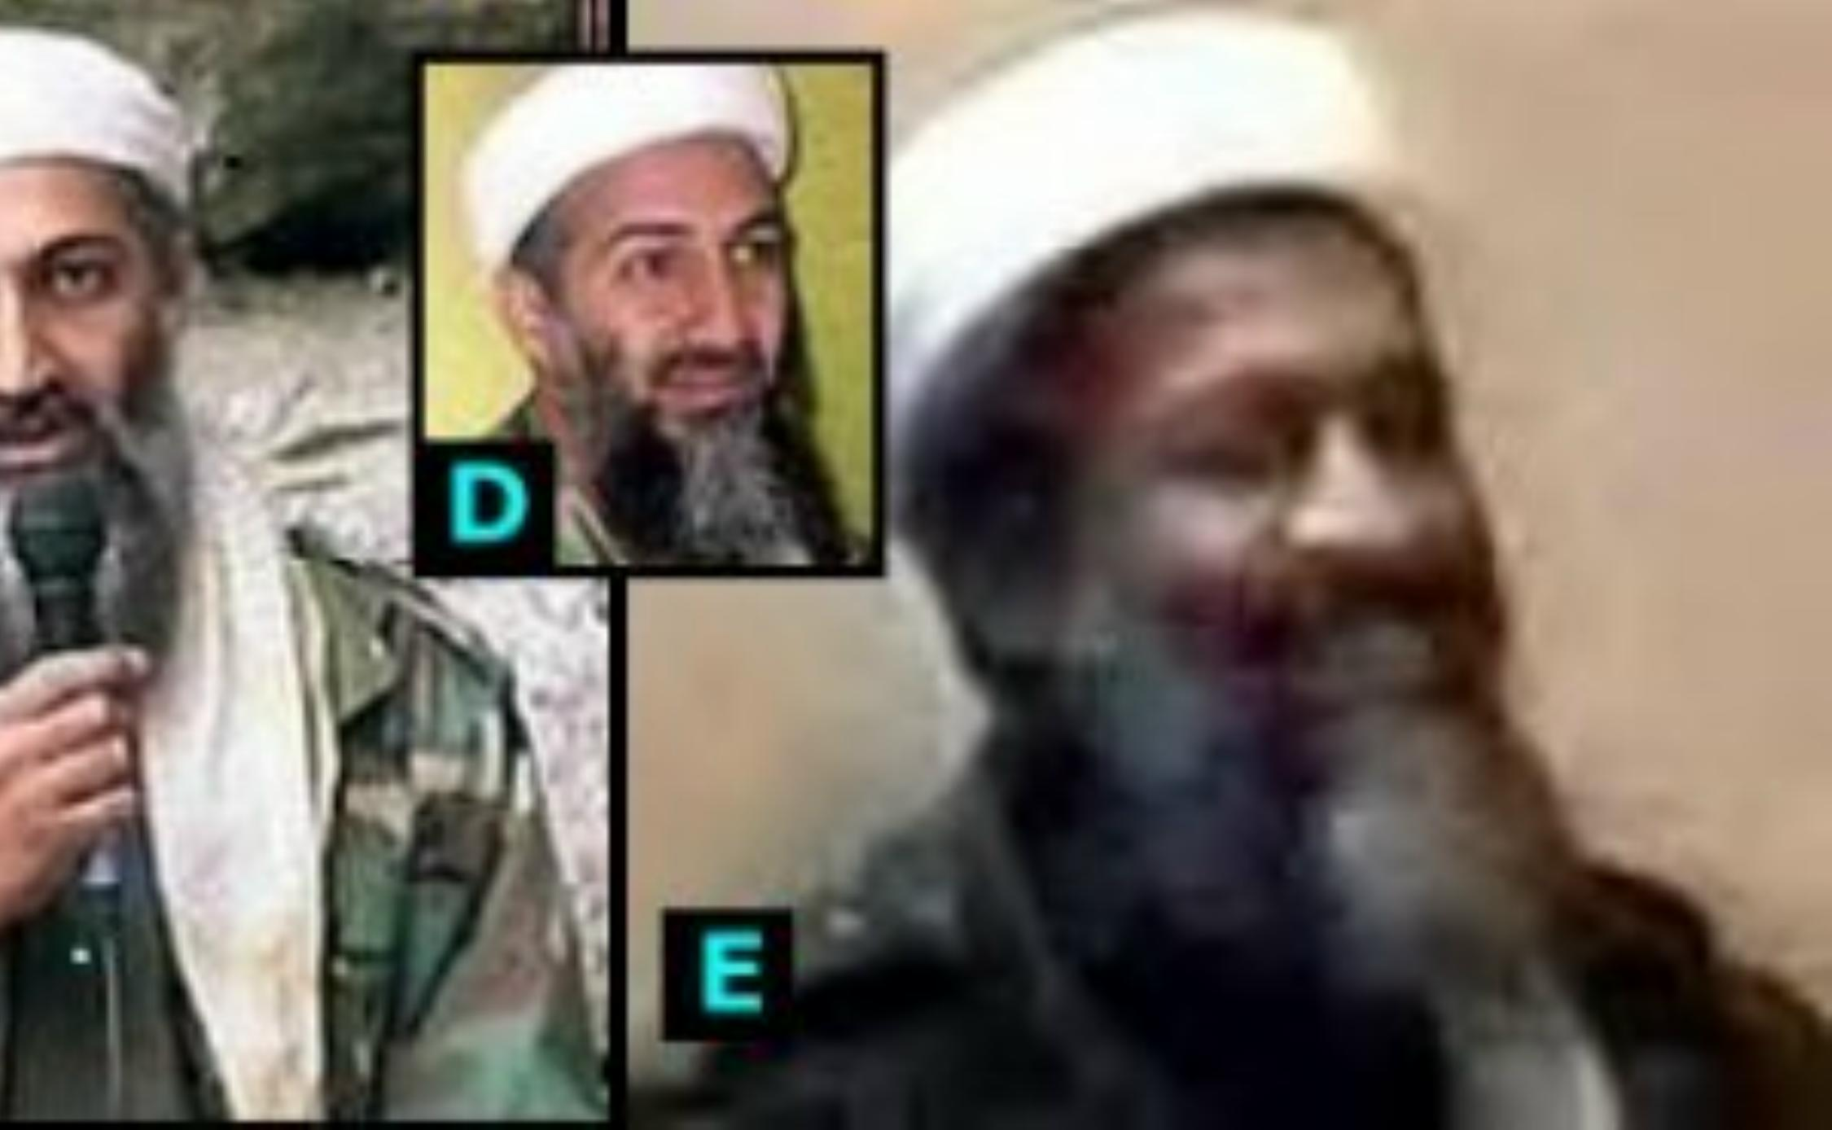
A thru D: Osama Bin Ladin  He is six foot six, and left handed, and a strict Wahabi Muslim who is forbidden to wear gold by his doctrine. |  |  | E: Osama Impersonator Hired by Bush's handlers for the Dec. 13, 2001 video "found" in a drawer in a house in Jalalabad, Afghanistan, a city of 100,000 people.  In this video, the "Fat-Nosed Bin Ladin", as he is known, writes with his right hand, and wears a gold ring and watch.  claims responsibility for 911, but makes many glaring errors, including praising hijackers who are still alive.
On Oct. 10th, 2001, in an interview with the Pakistani newspaper Ummat he denies all involvement with 911.
View the whole video and read all the details at http://www.whatreallyhappened.com/osamatape.html

