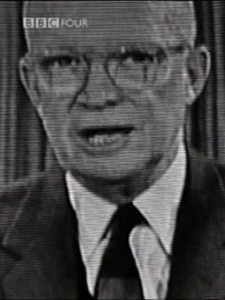
Eisenhower's Farewell Speech
"This conjunction of an immense military establishment and a large arms industry is new in the American experience. The total influence – economic, political, even spiritual – is felt in every city, every Statehouse, every office of the Federal government. We recognize the imperative need for this development. Yet we must not fail to comprehend its grave implications. Our toil, resources and livelihood are all involved; so is the very structure of our society.

In the councils of government, we must guard against the acquisition of unwarranted influence, whether sought or unsought, by the military-industrial complex. The potential for the disastrous rise of misplaced power exists and will persist.

We must never let the weight of this combination endanger our liberties or democratic processes. We should take nothing for granted. Only an alert and knowledgeable citizenry can compel the proper meshing of the huge industrial and military machinery of defense with our peaceful methods and goals, so that security and liberty may prosper together."

