NARCOTICS
behind the great fortunes that the CIA was created to protect
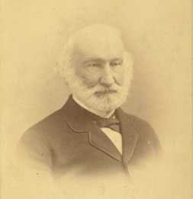 | William H. Russell (Skull & Bones; co-founder-1833) cousin Samuel Russell formally established Russell & Co. on January 1, 1824 for the purpose of acquiring opium and smuggling it to China. Russell & Co. merged with the number one US trader, the J. & T.H. Perkins "Boston Concern" in 1829. By the mid-1830s the opium trade had become "the largest commerce of its time in any single commodity, anywhere in the world." Russell & Co. and the Scotch firm Jardine-Matheson, then the world's largest opium dealer working together were known as the "Combination." [thanx to http://www.ctrl.org/boodleboys/] |  |  |  |  |  |  | 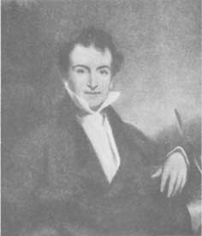
Col. WH Russell in his later years | "When we sold the Heathen nations rum and opium in roll / And the Missionaries went along to save their sinful souls."  "The Old Clipper Days" — Julian S. Cutler |  |  |  |  |  |  | Samuel Russell of Middleton, Ct.
Other great New England families related by blood to Perkins and the opium fortunes include Cabot, Lowell, Higginson, Forbes, Cushing, Sturgis, Coolidge, Alsop, Delano, and Weld
The Opium Trade began with the British (and American) love of tea. So much tea was purchased in China, and so little of value was bought by China in return, that Anglo-American silver began to be depleted. Opium was the solution to this problem. Bengali (lowland) and Afghan (highland) opium was smuggled into China, against the laws of the Chinese Empire, and sold for silver, which could then be turned around to buy tea. The quantity grew from 15 tons in 1730 to 75 tons in 1773 to 900 tons by the 1820's. This was the same British East India Company whose subsidized tea was dumped in Boston Harbor. |  |  |  | 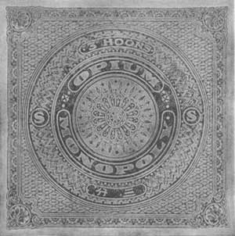  Wrapper for opium —Singapore c.1920 | When finally a ship was seized and the cargo destroyed, London sent Royal Marines and warships to what became the First Opium War, devastating the coasts of China. The Emperor was forced to relent, and the lucrative, insidious trade went on apace. In 1842 the Qing authorities sued for peace, which concluded with the Treaty of Nanjing negotiated in August of that year and ratified in 1843. In the treaty, China was forced to pay an indemnity to Britain, open five ports to Britain, and cede Hong Kong to Queen Victoria. The Second Opium War, more of the same, was fought from 1856-1860, and extorted more unwelcome trade opportunity in China, as well as five million ounces of silver.
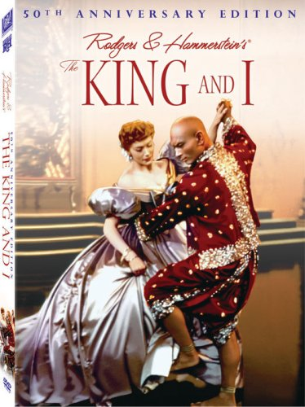  "Shall We Dance?" |  | AT ITS START IN THE EARLY NINETEENTH CENTURY, SIAM'S THRIVING OPIUM TRADE simply reflected the size of the Chinese population. As the Bangkok dynasty imported legions of Chinese laborers for construction of canals across its central plains, its Chinese population became the largest in Southeast Asia, reaching 440,000 in 1821 and constituting half of Bangkok by 1880.  And with the Chinese came the opium problem. In 1811 King Rama II promulgated Siam's first formal ban on the sale and consumption of opium. In 1839 another Thai king reiterated the prohibition and ordered the death penalty for major traffickers. Despite the good intentions of royal courts, legislative efforts failed. Although Chinese distributors could be arrested and punished, the British merchant captains who smuggled the illicit narcotic were virtually immune to prosecution. Whenever a British captain was arrested, ominous rumblings issued from the British embassy, and the captain was soon freed to smuggle in another cargo. Finally, in 1852, King Mongkut bowed to British pressure and established a royal opium franchise that was leased to a wealthy Chinese merchant.
 |  | —————————  MOVING TO THE MODERN ERA we see that what are called in Europe "secret services", and in the U.S. "intelligence agencies" always need more money for their activities than they are given by their governments, especially for their so-called "covert" activities — ie., not for gathering information, but for destroying other governments in secrecy. |  |  |  |  | 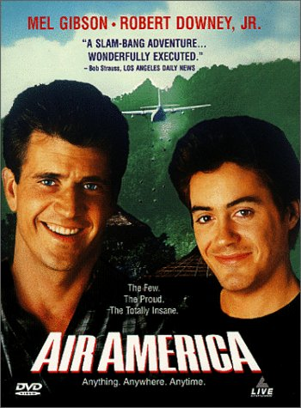
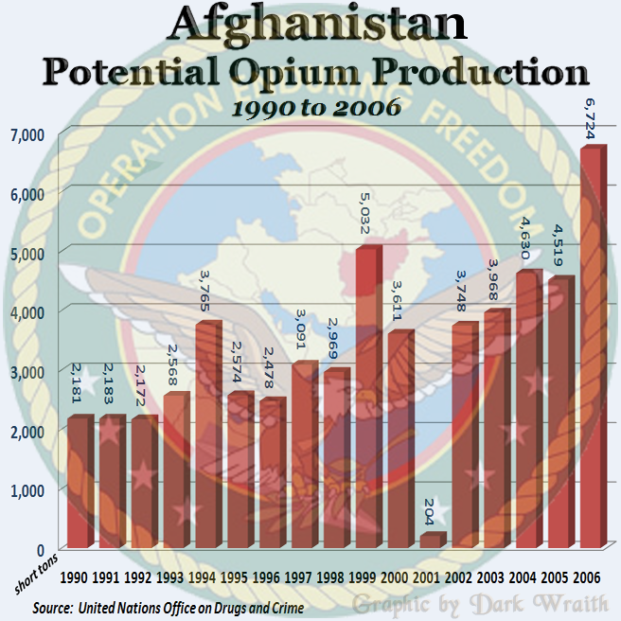 |  |  | AIR AMERICA, now a radio network, was originally the CIA's private airline, used to facilitate its operations, especially in Vietnam, Laos, Cambodia, Burma, and Thailand. At the end of World War II, the opium trade was already the primary source of funding for running the colonial French and British governments of these regions, that is, opium grown in the highlands by Hmong tribespeople and extracted as tax by the colonists, to be sold in the cities, most especially Saigon, the largest opium market in region. The money was used to fight the insurgencies that wanted the colonial governments out.  AIR AMERICA was a movie in 1990 featuring Mel Gibson that accurately portrayed the heroin trade conducted by the CIA.
⬅THE TALIBAN BROUGHT OPIUM PRODUCTION TO A VIRTUAL STANDSTILL IN 2001. Lucky for the CIA's coffers, that was quickly ended by Bush's wars in Afghanistan and Iraq. "In my thirty year history with the DEA,"
said Dennis Dayles, who spent the 1980s as that agency's chief of enforcement in Central America, "the major targets of my investigations almost invariably turned out to be working for the CIA."
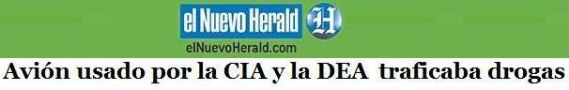
[CIA Torture Plane Crashes with 3.3 Tonnes of Pure Cocaine]
Miami Herald — Spanish Version
BOGOTA — 11/29/07 — G.GUILLEN — El Nuevo Herald
Un jet ejecutivo que el gobierno de Estados Unidos usó durante año para extraditar delincuentes desde Colombia y talibanes desde Europa a la base de Guantánamo, Cuba, es el mismo que have dos meses se precipitó a tierra en una selvática zona de la península de Yucatán, México, con un cargamento de 3.3 toneladas de cocaína que, al parecer, fueron cargadas en Medellín, en donde hizo el último despegue.
El avión, un Gluf Stream II, de matrícula norteamericana N987SA, era célebre en Colombia porque durante años en él fueron embarcados en Bogotá centenares de delincuentes para ser puestos en poder de la justicia estadounidense.
 |  |  |  |  |  | 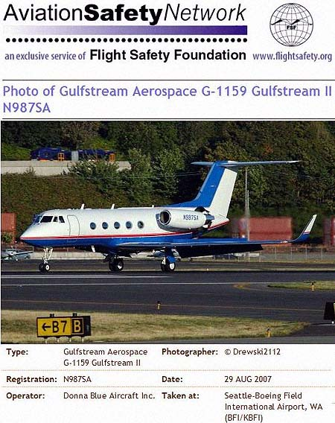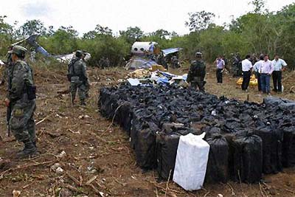
[ "An executive jet which the government of the United States used this year to extradite delinquents from Colombia and Taliban from Europe to the base at Guantánamo, Cuba, is the same which crashed to earth two months ago in a forested region on the Yucatán Peninsula of Mexico, with a cargo of 3.3 tonnes of cocaine, which apparently were loaded in Medellin, where it last took off.
The plane, a Gulf Stream II, with North American tail-numbers N987SA, was in the news in Colombia because for years in Bogotá, hundreds of prisoners were carried on it under the power of the the justice system of the United States."]

